Managing inventory is important for risk management

OPTION VALUE = intrinsic + extrinsic

FUTURES PRICE CHANGES FOLLOW A LOG-NORMAL CURVE/DISTRIBUTION -> the volatility/probability of an outcome/change is given by the log-normal curve/distribution

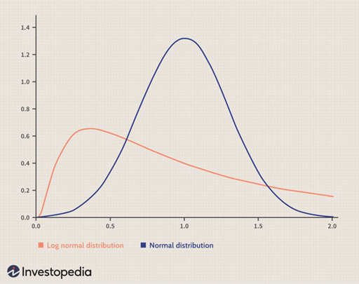

$$σ=implied volatility of the oil future price=SDV$$

$$SD= \sqrt{\frac{\sum{({P-P^{bar})}^{2}}}{N}}$$

$$SDV= \sqrt{\frac{\sum_{i=1}^{N}{({\ln{(\frac{P_{i}}{P_{i-1}})}-\frac{1}{N}\sum_{j=1}^{N}{\ln{(\frac{P_{j}}{P_{j-1}}}}))}^{2}}}{N-1}}$$

implied volatility which is calculated from the current price of an option by working out the BSM for $σ$.

**GREEKS + Other risks**

$$Vega=\frac{Change in option price}{1\% change in implied volatility}$$

$$Vomma=\frac{Change in vega}{Change in implied vol}=\frac{∂vega}{∂σ}$$

$$Veta=\frac{Change in vega}{1 day}=\frac{∂vega}{∂t}$$

$$Theta=\frac{\$Change in option value due solely to the decay of time}{1 day}$$

$$Rho=\frac{\$Change in option price}{\$Change in carry cost}$$

$$Δ (A.K.A. HEDGE RATIO)= \frac{\$Change in option price}{\$Change in oil future price}$$

OTM -> 0

ATM -> 0.5/-0.5

ITM -> 1/-1

Changes in delta w.r.t changes in the underlying (gamma)+ time to expiry (charm) + implied volatility (vega) = delta sensitivity (need for proper hedging)

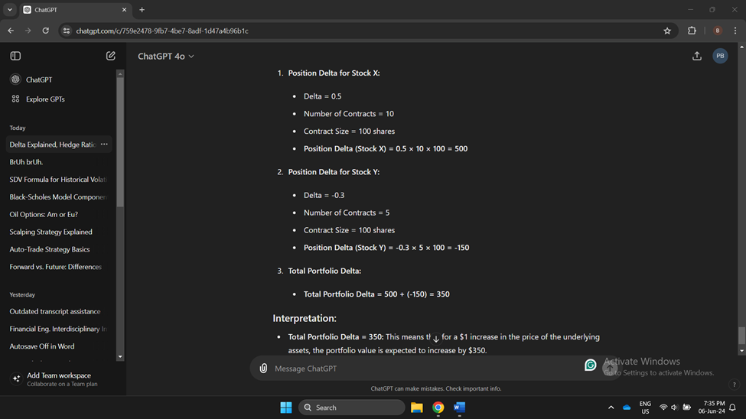

**DELTA SENSITIVITY (SECOND ORDER DERIVATIVES) – directly affecting delta**

$$Gamma(Γ)=\frac{Change in ∆}{\$Change in the oil future}= \frac{∂∆}{∂S}$$

$$Charm (time delta risk)=\frac{Change in ∆}{1 day}=\frac{∂∆}{∂t}$$

$$Vanna=\frac{Change in ∆}{Change in implied vol}=\frac{∂∆}{∂σ}$$

$$Phi=\frac{Change in ∆}{\$Change in carry cost}= \frac{∂∆}{∂c}$$

$$Epsilon=\frac{Change in ∆}{\$Change in interest rate}= \frac{∂∆}{∂r}$$

**GAMMA SENSITIVITY (SECOND ORDER DERIVATIVES) – indirectly affecting delta**

$$Color=\frac{Change in gamma (Γ)}{1 day}=\frac{∂Γ}{∂t}$$

$$Zomma=\frac{Change in gamma (Γ)}{\$Change in the underlying}=\frac{∂Γ}{∂S}$$

**SKEW RISK**

A flat skew means that all calls/puts (u treat them independently) trade at the same implied volatility regardless of the strike. Positive skew is when the ITM and OTM have higher implied volatility than the ones closer to the center (which is ATM). A negative skew means the implied volatility is higher at the center (so closer to ATM) and lower at the wings (like well ITM and OTM).

There are 2 skews: a put skew and a call skew. The skew shows how implied volatility varies across put/call strikes. The degree of skew is related to option expiration cycles. Options that are furthest from expiration (+6 months) present a flat skew. The ones in the middle range (3-6 months) have a more U (I mean more flat though not perfect U) skew (flat ATM and curved at the wings). The closest options to expiration (less than 3 months) have an even more pronounced U (not perfect though).

As an options trader you always want to know where the ATM straddle is trading both in terms of the price but also in terms of the implied volatility.??????????

**PIN Risk**

Price Fluctuations: If the underlying asset’s price is near the strike price at market close on expiration day, there's uncertainty about whether the option (ATM) will be exercised. Final exercise decisions might be influenced by after-hours trading or the final settlement price.

Market Close Impact**:** The option’s fate is determined by the settlement price or closing price, which can differ slightly from the last traded price due to after-hours movements.

**Liquidity risk**

It refers to the risk that an option cannot be traded quickly enough in the market to prevent a loss or to meet a trading objective without a significant impact on its price. This is a crucial consideration for options market makers, who need to maintain the ability to enter and exit positions efficiently.Slippage: In illiquid markets, it may take longer to execute orders, increasing the risk of unfavorable price movements during the execution delay.

**To do:** 1. *Market Depth Analysis:* Regularly analyze the market depth and trading volume to assess liquidity conditions before entering large positions. Low Volume: Options with low trading volume may have limited liquidity, making it difficult to execute large orders without affecting the price. Low Open Interest: Low open interest indicates fewer outstanding contracts, which can also signal lower liquidity.

*2. Use limit orders* to control the price at which trades are executed, reducing the impact of wide bid-ask spreads.

*3. Gradual Positioning*: Enter and exit positions gradually to minimize market impact, particularly in less liquid options.

*4. Inventory Management:* Market makers need to balance their inventories to avoid holding large positions in illiquid options that are difficult to unwind (i.e. diversify)

**Operational Risk**

*Trade Execution Errors*: Mistakes in executing trades, such as incorrect order entry, delays, or mismatched trades.

*Settlement Issues*: Problems with clearing and settling trades, including mismatched trade confirmations or failures in settlement processes.

*Unauthorized trading activities*

**CORRELATIONS**

Correlation between the spot price and the agreed upon future contract prices.

Correlation between the prices of futures with different expiration days.

Correlation between benchmarks/grades. You could trade spreads between grades and nned that corr.

Corr between crude oil and refined products (diesel, gasoline)

Seasonal patterns (summer deriving for fuel oil)

Corr between oil prices and economic growth/indicators

**FX risk**

An increase in interest rate makes the dollar more strong so it makes oil more expensive to investors holding other currencies. This can reduce demand for oil so prices could go down.

An increase in interest rate makes the carry cost more expesive which makes holding future contracts less appealing which means there is less demand for them so this leads to lower price.

Fixed-income becomes more attractive so less money flows ad demand into oil which calls for a lower oil price.

**Kurtosis Risk**

The risk that the probability of extreme price movements increases or decreases due to changes in the kurtosis of the underlying asset’s return distribution. The change in probability is given by market volatility (higer vol higher chances of extreme events), economic events, policy…

- Higher kurtosis = fatter tails, more extreme outcomes.

- Lower kurtosis = thinner tails, fewer extreme outcomes.

Options Pricing: Affects the value of far OTM options and mispricing if models assume normal kurtosis.

Risk Management: Complicates hedging and portfolio sensitivity due to unexpected large price moves.

Mitigation:

- Incorporate fat tails in pricing.

- Stress testing: Account for extreme scenarios.

- Diversify: Spread exposure to limit tail risk.

**Basis Risk**

The risk that the price difference (basis) between an underlying asset and its hedging instrument (e.g., futures) changes unpredictably

Basis=Spot Price−Futures Price

Here is the correlation analysis right between the spot and the future.

In my mind, backwardation is the result of basis risk, because either the sport appreciates suddenly or depreciates suddenly. The spot changes first, and then the futures adapt.

Basis Risk Causes:

1. Differences in supply and demand dynamics
2. Cost of carry (storage and financing costs)
3. Seasonal effects



**Hedging (not clear)**

1 You can adjust delta with futures as you knew, but that leaves you with the possibility of frequent whipsaw losses during the day. **Whipsaw Loss**: A financial loss incurred when the price of an asset moves sharply in one direction, leading a trader to adjust their position, and then reverses direction quickly, resulting in losses from the adjustment. Oil futures are generally more volatile than oil options.

2 A better way to adjust delta is to use options. A favorable delta adjustment occurs when puts or calls are mispriced with respect to each other. You ‘d buy the cheaper alternative and turn it into an opposite put/call synthetically. If the market is rising, then puts will be cheaper, and if the market is declining, then calls will be cheaper, but like cheaper than they should be, according to P-C-P. Buy the cheaper option and synthetically create the other option. I am basically saying if there is arbitrage. I guess you do this in anticipation of needing the option you create synthetically at some point to adjust your delta idk??

**Mistakes when hedging**

Another is to accumulate a negative vega position by being too exposed to one type of option. You should look for corresponding option spreads to trade off some of that risk. In reality, you could be delta neutral as required, but your vega risk is lopsided. The general rule is to remain net long vega.

*You want to analyze risks for options positions:*

**CALL SPREAD**

**vertical spread =** buying and selling two options of the same type (calls/puts) with the **same expiration date** but **different strike prices**.

**horizontal spread =** buying and selling two options of the same type (calls/puts) with the **same strike price** but **different expiration dates**.

Goal: Maximize profit by capturing the time decay difference between the short-term and long-term options. You sell the short-term option and buy the long-term option.

When you hedge using futures, you will pay money (that is, the difference between the $ value of the contract you hold and the $ price of the contract you wanna buy) to roll over and keep the exposure. This is a reason you would want to hedge using option spreads rather than future contracts.

**Contango and backwardation**

Both vertical and horizontal spreads can achieve delta-neutral positions. The choice depends on whether you prefer cost-efficiency (vertical) or flexibility in managing time and volatility (horizontal).

* **Contango**: Use spreads to mitigate negative roll yield and manage costs.
* **Backwardation**: Use futures to capture positive roll yield or spreads for flexible and controlled risk management.